**Introduction**

On June 20, 2024, the Department of Computer Science and Engineering (CSE) at Acharya Institute of Technology organized a seminar on CAT, GMAT, GRE, and other competitive exam preparedness. This seminar, conducted in collaboration with the CSE department forum LAKSHYA and Global Reach Academy (Mam Can You Change This), aimed to equip pre-final year students with the necessary tools and knowledge for excelling in competitive exams. The event took place in the Main Auditorium of ANA Block from 1:45 pm to 4:30 pm.

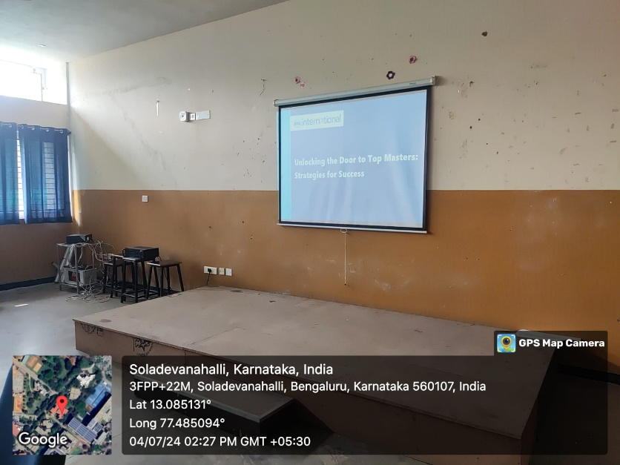

**Fig 1: - Seminar**

**Objectives**

The primary objectives of the seminar were:

1. To highlight the significance of aptitude tests.
2. To provide information on national-level management examinations.
3. To offer guidelines for facing personal interviews and group discussions.
4. To discuss job prospects post-BE.

**Discussion**

The seminar began with a welcome address by Prof. Kamala K, class teacher of the 6th C section and Prof. Varalakshmi B D, class teacher of the 6th A section, who emphasized the importance of career guidance for students. Certified counselors from Global Reach Academy (This also) conducted the session, sharing insights on higher studies abroad. They discussed the various challenges and opportunities associated with studying abroad, helping students make informed decisions about their professional paths.

The session covered the following key points:

* The importance of aptitude tests in competitive exams.
* Detailed information on exams like CAT, GMAT, and GRE.
* Strategies for personal interviews and group discussions.
* Potential career paths and job opportunities after graduation.

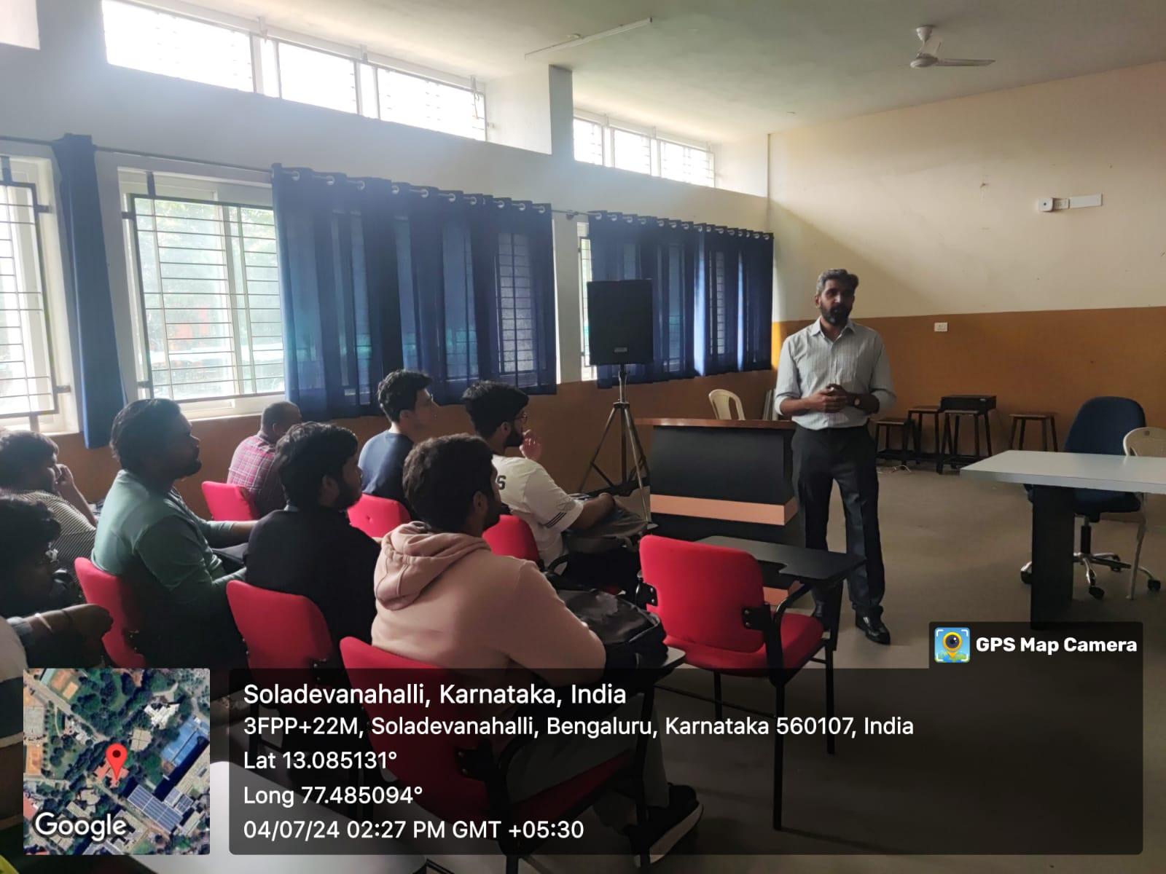

**Fig 2: - Sir Explaining**

**Conclusion**

The seminar was a valuable session for the students, providing them with critical insights into the preparation for competitive exams. The knowledge shared by the counselors from Global Reach Academy was instrumental in helping students understand the steps required to achieve their career goals.

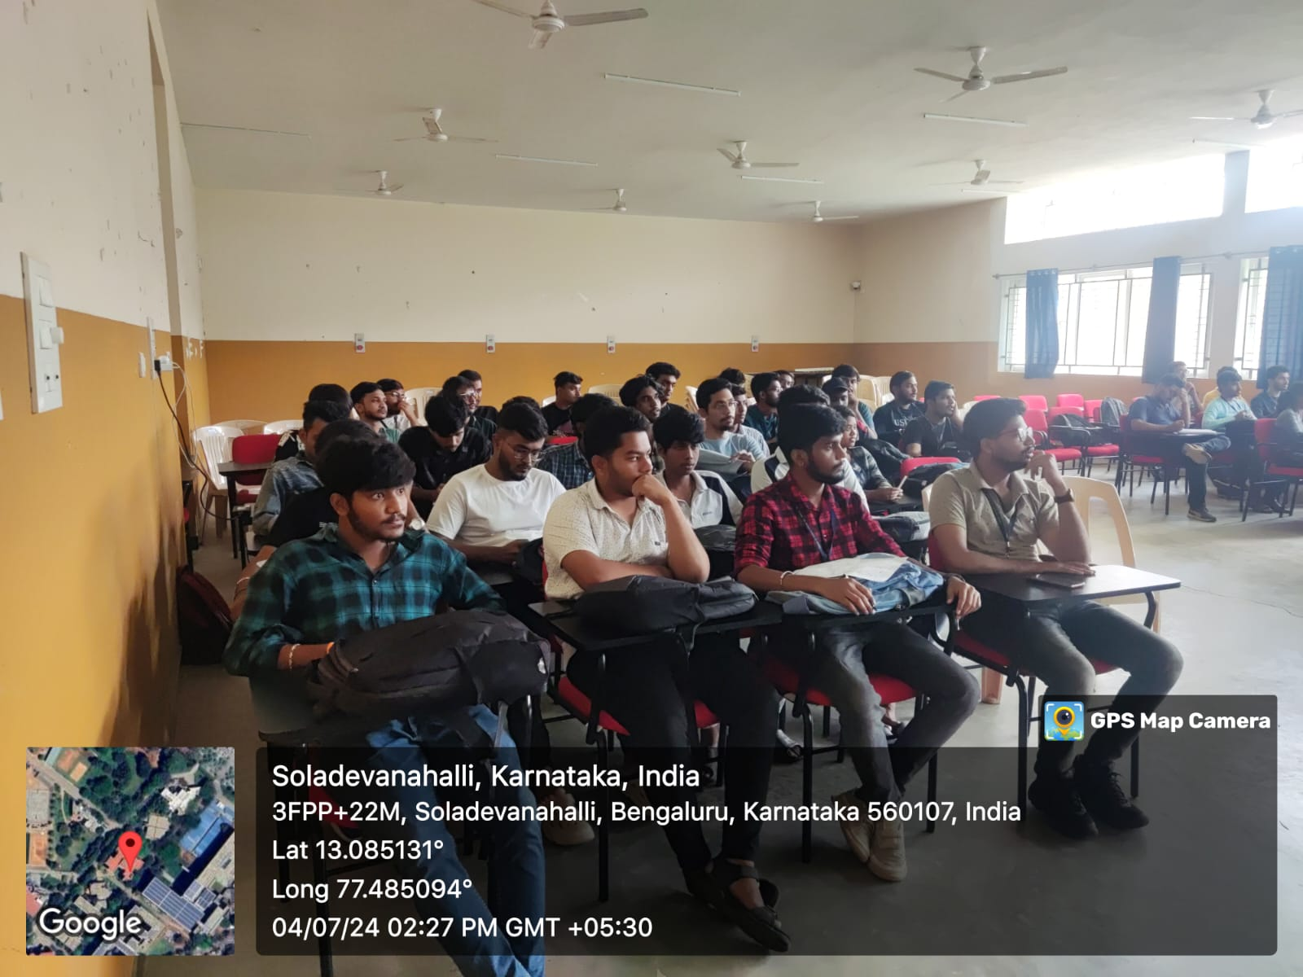

**Fig 3: - Students Attending**

**Future Scope**

Moving forward, the department plans to:

1. Organize more such seminars and workshops to cover various other competitive exams and career guidance topics.
2. Establish a mentorship program connecting students with alumni who have successfully cleared these exams and are pursuing higher studies or careers abroad.
3. Provide continuous support and resources for students preparing for competitive exams.

**Outcomes of the Seminar**

* Increased awareness among students about career and higher education options in India and abroad.
* Enhanced understanding of the importance of goal-setting and strategic preparation.
* Empowered students to make informed decisions about their future educational and professional goals.

**Acknowledgments**

The seminar was coordinated by Prof. Kamala K, Assistant Professor and Placement Coordinator of the CSE department. The efforts of the forum coordinators, Mrs. Varalakshmi B D and Mrs. Bhavyashree S P, along with the support of the HOD-CSE, Dr. Ajith Padyana, were instrumental in making this event a success.

**Forum Coordinators: HOD-CSE:**

Mrs. Varalakshmi B D Dr. Ajith Padyana

Mrs. Bhavyashree S P